LOGIN FORM

<!DOCTYPE html>
<html>
<head>
<title>Login Form</title>
<style>
body {
font-family: Arial, sans-serif;
background-color: #f0f0f0;
}

.container {
width: 300px;
margin: 50px auto;
background-color: #fff;
padding: 20px;
border: 1px solid #ddd;
box-shadow: 0 0 10px rgba(0, 0, 0, 0.1);
}

.form-group {
margin-bottom: 20px;
}

.form-group label {
display: block;
margin-bottom: 10px;
}

.form-group input[type="text"], .form-group input[type="password"] {
width: 100%;
height: 40px;
padding: 10px;
border: 1px solid #ccc;
}

.error-message {
color: #ff0000;
font-size: 14px;
margin-top: 10px;
}

.submit-button {
background-color: #4CAF50;
color: #fff;
padding: 10px 20px;
border: none;
border-radius: 5px;
cursor: pointer;
}

.submit-button:hover {
background-color: #3e8e41;
}
</style>
</head>
<body>
<div class="container">
<h2>Login Form</h2>
<form id="login-form">
<div class="form-group">
<label for="username">Username:</label>
<input type="text" id="username" name="username" required>
<div class="error-message" id="username-error"></div>
</div>
<div class="form-group">
<label for="password">Password:</label>
<input type="password" id="password" name="password" required>
<div class="error-message" id="password-error"></div>
</div>
<button class="submit-button" type="submit">Login</button>
</form>
</div>

<script>
const loginForm = document.getElementById('login-form');
const usernameInput = document.getElementById('username');
const passwordInput = document.getElementById('password');
const usernameError = document.getElementById('username-error');
const passwordError = document.getElementById('password-error');

loginForm.addEventListener('submit', (e) => {
e.preventDefault();

const usernameValue = usernameInput.value.trim();
const passwordValue = passwordInput.value.trim();

if (usernameValue === '') {
usernameError.textContent = 'Username is required';
} else {
usernameError.textContent = '';
}

if (passwordValue === '') {
passwordError.textContent = 'Password is required';
} else if (passwordValue.length < 8) {
passwordError.textContent = 'Password must be at least 8 characters long';
} else {
passwordError.textContent = '';
}

if (usernameValue !== '' && passwordValue !== '' && passwordValue.length >= 8) {
// Login logic here
console.log('Login successful');
}
});
</script>
</body>
</html>

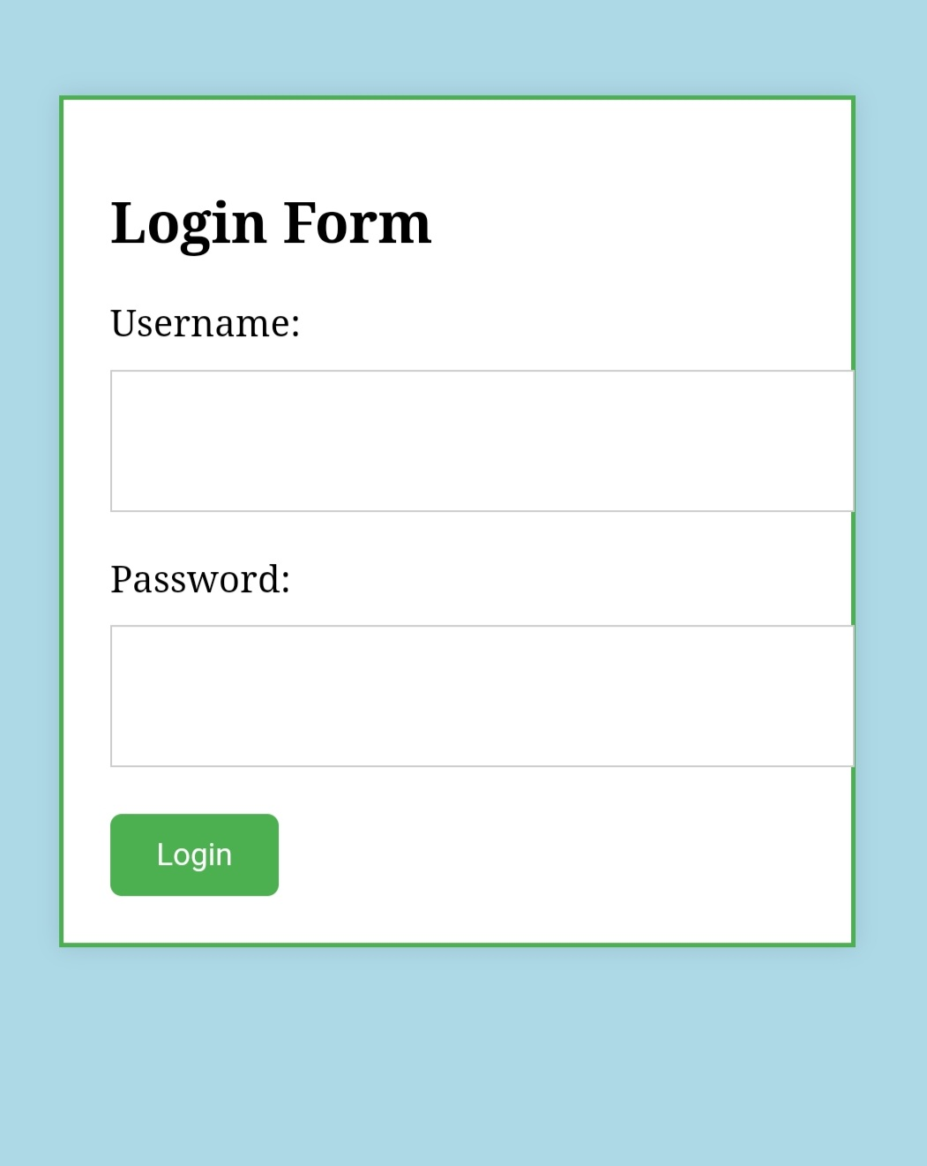
OUTPUT

